Career Episode 1
Design Review, Installation, Testing and commissioning of HVAC, Fire Fighting, Solar and Access Control Systems
- Introduction

- This narrative seeks to demonstrate my expertise as a mechanical engineer and an effective project manager, with reference to the Saudi Railway Project that I accomplished in 2012 while working with Saudi Bin Laden Group (SBG). The scope of my assignment that lasted between October 2009 and March 2012 was Design Review, Installation, Testing and Commissioning of HVAC, Fire Fighting, Solar and Access Control systems. In this assignment, I occupied the position of the Site Manager – Mechanical with the responsibility to coordinate with the joint venture partner, subcontractors and vendors, review design drawings and propose relevant modifications to the consultant, coordinate the procurement, delivery and quality inspections of the delivered equipment, and finally supervise the Installation, Testing and Commissioning of all electromechanical systems.
Project Details:
- Project Location: Hail University, Hail City, North-Western region of the Kingdom of Saudi Arabia (KSA)
- Project Owner: Saudi Arabian Railway
- Financier: Saudi Public Investment Fund (PIF)
- Joint Venture Partner: THALES Group
- Consultant: Systra & Loius Berger
Company Details:
- SBG Head Office Location: Jeddah, Saudi Arabia
- Website: www.sbg.com.sa
- Tel (Jeddah head office): 012-6400004
- Background
- The objective of Saudi Railway Project, currently referred to as the Signalling & Telecommunication – 100 (S&T 100) project was to provide an effective means of transportation of passengers and minerals from the Al Jalamid and Al Haditha mines located in the Northern Part of KSA to Ras Al-Kheir Complex located in the southern part of KSA. The Ras Al-Kheir Complex is a mineral processing facility comprising of an alumina refinery and a phosphate plant. The Saudi Railway, which was later to be connected to the Gulf Corporation Council Railway Network comprised of 2400km rail track, six passenger stations, two maintenance yards, eight intermodal terminals, three mining terminals and a total 173 telecom sites distributed along the railway track (See Figure 1).
- In 2009, SBG was awarded the ST 100 project in a joint venture with Thales Group. SBG’s scope of work was to plan and execute civil and electromechanical works for all the 173 Signalling and Telecom sites. The Telecom sites comprised of 40m high Towers, 5x3m or 6x6m shelters, fire fighting systems, HVAC systems, diesel power generators and accessories, solar systems, Operation Control Centres, stations and yards. Below is a snapshot of a section of the S&T-100 project showing the locations of shelters, buildings and towers along the railway tracks starting from Al Jalamid and Al Haditha mines.
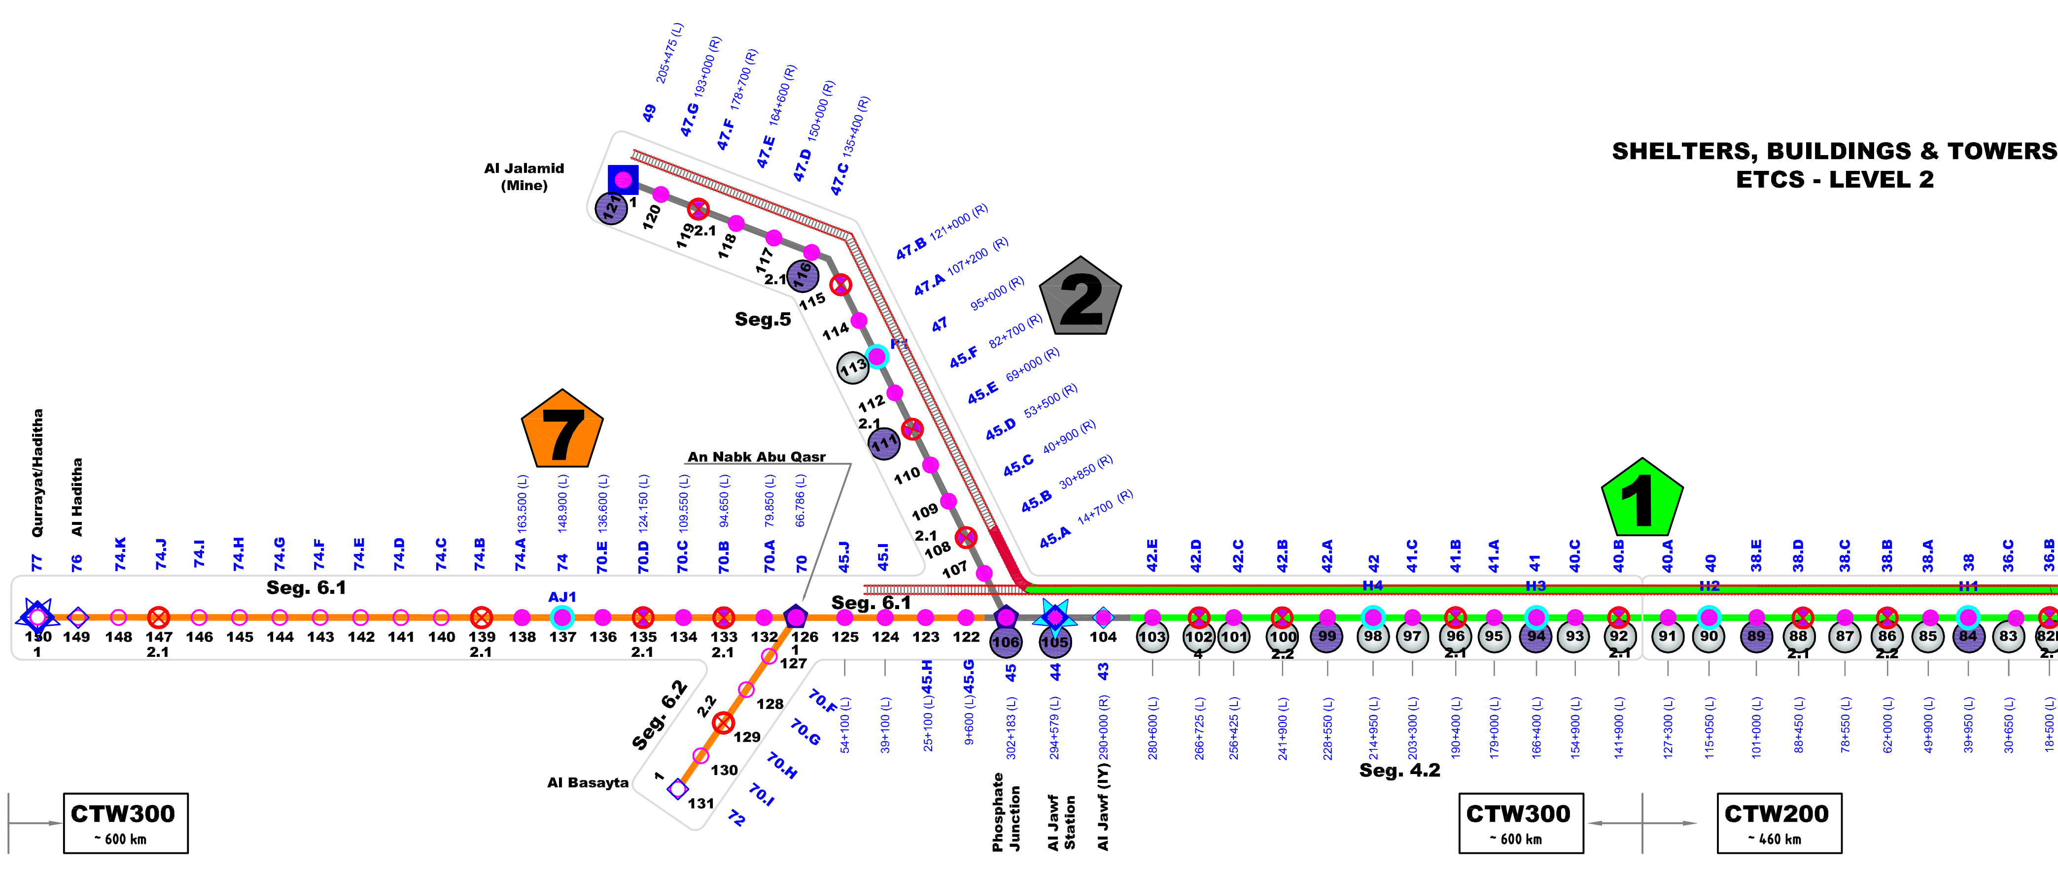
Figure 1: A section of the S&T-100 project (content visible at about 300% zoom level)
- When the project was awarded to SBG, I was appointed the Site Engineer – Mechanical. Official reporting was carried out as illustrated in Figure 2 below.

Figure 2: The SBG’s organizational chart – Saudi Railway Project
- The following were my specific duties in the Saudi Railway Project:
- I coordinated with the SBG Project Management Office (PMO), THALES Group Representatives, Vendors and Sub-contractors.
- I worked on holding Technical Interface meetings with the Client, Consultant and PMO officials.
- I participated in design review and proposing design modifications to meet client requirements.
- I reviewed the installation requirements for cables and HVAC ducts, selecting and sizing various parts of the supporting system including cable-trays, hanger rods and steel channels.
- I created the installation schedule and supervising the installation, testing and commissioning of the HVAC system, Fire Fighting System and Solar System.
- I reviewed resource requirements and managing the supply chain of materials, electromechanical work logistics and safety.
- I assessed manpower requirements, creating teams and workgroups, assigning responsibilities and working closely with the team leaders guarantee quality and timely completion of all activities.
- Personal Engineering Activity

- My knowledge in design and installation of HVAC systems, fire-fighting equipment and active fire suppression systems was supported by the basic concepts I assimilated from academic courses such as HVAC Design, Heat transfer, Thermodynamics and Fluid Mechanics undertaken during my bachelor’s degree studies. In addition, I had undertaken other relevant training programs offered by TUV/NORD, Riyadh-KSA and from APTECH-Pakistan as well including:
- ISO-9001 Awareness
- Internal Quality Auditing
- Health & Safety
- AutoCAD
- In my previous job with Orient Energy Systems, I had the opportunity to work on a 2MW power generation plant equipped with Fire Fighting Systems, both Auto-detection and Suppression Systems. The experience I had gained from the project placed me in a better position to accomplish my assignments in the S&T-100 project. Before starting the assignment, I conducted research on the design of fire suppression systems, fire detection technology, split and packaged HVAC systems, duct design and sizing of the extract and supply fans, diffusers and other components. I also obtained and conducted a detailed review of applicable sections of the ASHRAE standards for HVAC systems and NFPA-2001code for clean agent fire fighting systems.
- As part of the contract, SBG and THALES Joint Venture (JV) partners were required to submit the first Telecom Shelter prototype along with the required electromechanical installations to the client, SAR for approval. The same design and electromechanical installations were to be replicated in all the 173 Telecom Sites. The client suggested that the designed 173 shelters should be manufactured by Coldstores Group of Saudi Arabia (CGS-Riyadh) and provided with two externally mounted air conditioners. During the design phase, a concern was raised by the Client on the effectiveness and reliability of the installed fire suppression system in the case of a fire incident and false alarms.
- I used my previous experience with Orient Energy Systems to address the false alarm concern by suggesting and implementing a revised operation sequence of the fire detection mechanism. I employed the cross-zone detection approach in which a verification measure is incorporated before initiating the alarm. I achieved this by dividing the fire detection zone into two subzones A and B. For subzone A, I selected a smoke detector, while for subzone B, I selected a heat detector. In operation, the fire alarm would only go off when the detectors installed in both zones are triggered by the presence of smoke and heat. This helped in increasing the reliability of the detection mechanism by minimizing the probability of false alarms. I completed the remaining sequence as follows:
- When the fire alarm goes off, the HVAC system is shut down including motorized smoke dampers on return and supply grills and the externally mounted air conditioners.
- Immediately the HVAC system is shut down, FM-200 gas is discharged in the shelter to suppress and extinguish the fire.
- Problem: At this stage, there were some concerns on the effects of residues of FM-200 gas on the HVAC system and other electromechanical systems.
Solution: As the technical decision-maker, I evaluated the case, consulted with other experts and conducted extra research on the methods of extraction of FM-200 gas residues from an enclosure. I finally proposed the use of a smoke purging fan to extract the residues before turning on the HVAC and other electromechanical systems. I prepared my proposal and forwarded it to the Client in person for approval. In a meeting with the client about pending issues, I gave a detailed oral justification of the solution and finally got the nod to proceed.
- When I received the HVAC system drawings from the AutoCAD Operator, I launched AutoCAD Software and initiated the preparations for the installation stage. I started by studying the layout of the ducts and other system components in the operation control center to determine the best support mechanisms to be employed during installation A snapshot of a section of the duct layout is shown in Figure 3 below.
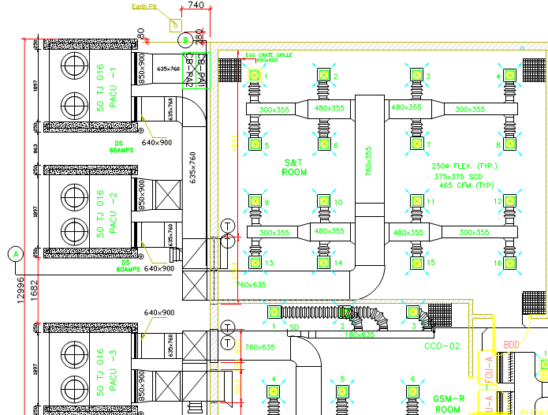
Figure 3: HVAC Drawing Snapshot – Duct Layout
- My aim was to select appropriate duct support hanger channels and tie-rods based on space constraints, loading and operating requirements of the HVAC system. I selected rectangular hanger channels and performed relevant calculations to determine the required sizes based on loading and space constraints. After this, I identified special attachments to be used to attach the hangers to the ceiling of the operation control centre. The ceiling attachments and channels were to be sourced from the manufacturer, HILTI UAE and delivered by a local supplier, affiliated to the manufacturer. The ducts were to be fabricated by CGS-Riyadh as instructed by the client.
- When the electrical and telecom work was completed, I was assigned the responsibility to collaborate with the Electrical Engineering and Telecom Teams to design the cabling support system. Since electrical cables could not be supported together with communication cables, I had to work on two separate support systems. After reviewing the cabling layout drawings using AutoCAD software, I advised the team to use cable-trays to secure the cables to the operation control centre. Next, I conducted a detailed review of the cabling layout diagrams along with the layouts of the HVAC and fire suppression systems to avoid clashing between cabling work and mechanical services. I identified a few clashing areas and subsequently requested the team to offset the cable layouts accordingly to solve the problem.
- I selected M10 zinc-plated steel hanger rods and W1-40 cable trays designed and tested as per IEC 61537. I referred to the deflection-load graphs provided by the manufacturer (HILTI) along with the load and dimensional data provided by the teams to select the appropriate sizes of cable trays and calculate the required spans. This also helped me to determine the support requirements; hence, the sizes of the supporting hanger rods. The sizes of the cable trays ranged from 200mm to 600mm in width and 1800mm to 2000mm in length. For all the cable trays with widths of more than 300mm, I included an extra support bracket and a joint of type W7-40.
- Before selecting the diameter of the hanger rods for each section, I consulted the ASCE 7 standard and performed relevant calculations to support my decision. I started by calculating the combined load acting on each member followed by the nominal unthreaded-area of the rod. However, the large number of hanger rods used to support the cable trays and the HVAC duct channels made it difficult for me to document the calculation results. As a result, I developed a solution by applying my basic computer skills to create an MS Excel Sheet, complete with equations and columns for all variables and results.
- Following the procedure recommended in the ASCE 7 standard, I derived the equation for the diameter of each hanger rod and entered it into the MS Excel Sheet to complete the calculation process in a single stage. The formula is shown below:
$$d_{rod}= \sqrt{\frac{16P_{u}}{3πφσ_{u}}}$$
Where; $P_{u}=Combined load on the hanger rod$
$$φ=Resistance factor$$
$$σ_{u}=Ultimate tensile strength of the rod$$
Finally, I used the calculated diameter to select the actual diameter of the rod from the manufacturer’s catalogue.
- Before starting the installation phase, I met with the Construction Manager (CM) to deliberate on important project requirements including priority of sites, manpower, materials and logistics. Taking into consideration the time requirement, I developed the installation schedule using MS Project software and later discussed it with the CM. I listened carefully to his views and instructions and made relevant adjustments to the schedule. I held meetings with the members of my team, divided them into groups, appointed team leaders and gave specific assignments to each group. Before embarking on any installation work, I led the teams to carry out quality inspections and tests on all delivered materials, equipment and components. Where quality requirements were not met, I suggested a replacement of the identified item before proceeding.
- I studied the safety guidelines of the company and defined the necessary safety checks and procedures to be followed during installation. I summarised the details and developed a Safety Management Plan (SMP) that became crucial during the execution phase. As per the SMP, I ensured that all the safety measures were in place and the correct PPE (Personal Protective Equipment) provided to the personnel before the commencement of any onsite work. As most of the work was performed on the embankment near the rail track, I had to coordinate with other teams involved in track laying and load testing. Since the teams were from Chinese Companies, language barrier became an impediment. However, I managed to communicate with them through interpreters to discuss the schedules and plan activities to avoid accidents and other safety incidences on the site.
- Summary

- The broad nature of this project meant that I had to work with multiple teams and experts involved with planning and execution of activities such as civil and electromechanical design, track laying and load testing, construction of shelters, fabrication work, and installation and testing of HVAC and fire suppression systems, solar systems, telecommunication systems and diesel generator sets. I utilized my management skills to develop schedules and lead the teams working under my leadership to carry out all tasks in accordance with the quality and time requirements. I was also actively involved in the design phase, and my contributions were incorporated into the final designs as discussed in the previous section of this CE. I successfully handed over the Signalling and Telecom sites and the operation control centre to the consultant and the client along with the required commissioned subsystems including the HVAC, Fire Fighting and solar systems. With the implementation of the technical objectives in the work, there was an adequate improvements which I made in my mechanical engineering knowledge.
Career Episode 2
Construction of New 110/13.8 kV Arafat-2 Substations
- Introduction
[CE 2.1]
Project: Construction of New 110/13.8 kV Arafat-2 Substations
Duration: 2012 – 2014
Location: Makah-Kingdom of Saudi Arabia
Organization: Saudi Technologists Consulting Engineers
Position: Mechanical Consultant
- Background
[CE 2.2] Saudi Technologists Consulting Engineers (SATECH) established in the year 1982. Which holds the membership of the Chamber of commerce and industry in the Eastern Province of Saudi Arabia. SATECH provides sound services for engineering services for a vast variety of trades.
[CE 2.3] The objective of 110/13.8 kV substations was indoor GIS type substations which were built to keep the loading of the existing substations within its firm capacity and to meet with the growing power requirements of the respective region. The working was executed on the HVAC system along with carrying out other mechanical system installation. There were various factors analyzed in the project tenure and achieved the work results using the mechanical engineering concepts.
[CE 2.4] The work nature was based on the construction of new 110/13/8kV substations in which I executed my duties as a Mechanical Consultant. The client was National Grid, subsidiary of Saudi Electricity Company and Projects were Construction of New 110/13.8 kV substations. Substation building was comprised of 03 Nos. of 50/60 MVA Power Transformer, 110 kV Gas Insulated Switchgear room and its basement, 13.8 kV Switchgear room, and its basement, Control room, communication room, and battery room. External Telecom shelter, 02 Nos. Auxiliary transformers, Neutral Grounding Resistor, and Capacitor Bank.

[CE 2.5] Hierarchy:
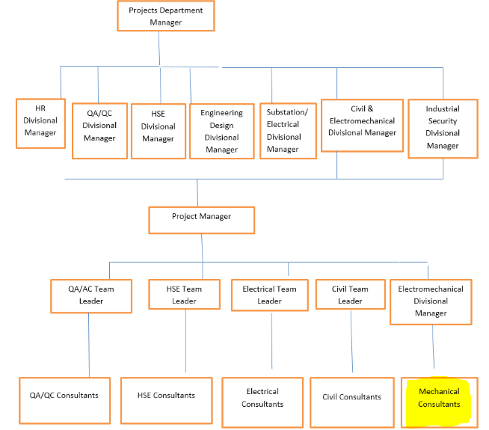
[CE 2.6] Responsibilities:
- I executed the design coordination with the Design review team of the client (National Grid) and Main Contractor/sub-contractors as per PTS/SOW in compliance with SEC standards and International standards.
- I attended weekly/monthly meetings with Client/contractor/subcontractors and Vendors.
- I analyzed submitted a master schedule for meeting deadlines of electromechanical work timely in compliance with QMS & HSE procedures.
- I made verification of the equipment which was dependent on the operation in an appropriate manner with adjustment, balancing, and testing.
- I managed electromechanical work at sites; material inspection, installation, testing & commissioning of the HVAC system (Package Units/Ducting/Diffusers/Exhaust/Smoke Purging Fans/DDC Control Panel/Sensors/Devices), Fire Protection System (auto-detection & suppression by clean agent/portable Fire Extinguishers), Plumbing (Pumps) and OHT/JIB Crane.
- I was responsible for the evaluation of the site mechanical engineer from the main contractor and sub-contractors.
- I implemented QMS & HSE procedures.

- Personal Engineering Activity
[CE 2.7] When I took the charge of Arafat-2 substation, I have given the responsibility to overcome the issue of FM-200 cylinders which were installed inside a 13.8 Switchgear basement room (inside protected area). Whereas, due to future maintenance of FM-200 cylinders, the proposal was rejected by Industrial Security Department that for future maintenance, how 600 lbs (06 Nos. cylinders) will be removed from the protected area for re-filling, where several low medium voltages and high voltage cables are laid in surroundings of FM-200 cylinders. What I did, there was not enough placement area for FM-200 cylinders in the basement staircase (outside 13.8 Switchgear room/protected area). So, I recommended shifting the FM-200 cylinders just above the basement (13.8 Switchgear room –Ground floor). Through which, FM-200 flow was achieved within 10 sec as per the NFPA-2001 requirement and got an appreciation letter from the vice president of the National Grid-Saudi Electricity Company.
[CE 2.8] I participated in the design flow calculation of the FM-200 system for 13.8 Switchgear room. I executed the HVAC Design (HAP software) Course from the National Institute of Design and Analysis. I took the Project Management Course (Primavera-P6) course from the National Institute of Design & Analysis, Karachi-Pakistan. Due to the course attended of HVAC Design, it was an easy task to review the technical design submittal of the HVAC system throughout my projects. For instance, I verified the required CFM in different areas of 110/13.8 kV substations. I executed the fire protection system which was based on operational impacts for a defined time interval. It assisted in saving costs and equipment was replaced with adequate components. I implemented the system which worked on immediately suppressing the fire and notifying the authorities for sending emergency professionals.
[CE 2.9] I initiated the working with the commissioning which occurred during the HVAC system installed within the existing building. At another stage, I executed the retro-commissioning which was implemented in the HVAC equipment. I then conducted the evaluation on each step which was accomplished with the verification, improvement, and documentation of the HVAC systems performance analysis. I executed the proper commissioning which was based on the determination with the HVAC commissioning process. I commissioned the process which was initiated with checking the HVAC equipment after the installation. I conducted a thorough check which included correct equipment verification and installing it in the proper location. Furthermore, I verified the installation requirements related to construction details and met the requirements. I worked on preparing the checklist along with documentation of the installed equipment. With the correct equipment verification, I installed the material with the equipment operation. I included the startup, shut down, and operational sequence. I analyzed the issues related to the operational sequence which was based on reporting to the necessary contractors. I verified the equipment which was based on operation in an appropriate manner along with testing, adjustment, and balancing.
[CE 2.10] I prepared the report on NDT for welding of rail-girder for over-head traveling crane of the GIS room. I worked on a leading team of contractor/sub-contractor/vendors in aspects of electromechanical work. I executed the plumbing work which interpreted building specifications for mapping layout for pipes, drainage systems, and other materials. I installed pipes and fixtures with further installation maintained for pipes, equipment, and installation. I assembled valves and fittings for installation which was further based on modifying pipes, fixtures, and plumbing materials. I utilized saws and pipe cutters as required which was followed with air-conditioning system installation. I made collaboration with construction workers, contractors, and steamfitters in repairing and installing works. I did plumbing systems testing for leakages and other related issues. I analyzed issues and identified appropriate tools along with materials for repair. Furthermore, I selected plumbing materials based on budget, location, and intended utilization of the building. I followed the health and safety standards which complied with building codes. I wrote reports and documenting the issues and actions summary prepared accordingly. Furthermore, I performed plumbing systems inspections for the identification and replacement of worn parts. I did bids preparation along with schedules and oversee the working activities of the team members.
[CE 2.11] I executed the duct system in the cooling process which consisted of tubes specifically assisted in distributing the cooled air in different rooms. I set the branching network which consisted of sheet metals and was designed for supplying rooms with air that was conditioned. I circulated the same volume that was back to the HVAC equipment. I obtained the air-duct systems which lose 25% of the cooling. I analyzed the duct leakage which was based on engaging and maintaining health and safety. I attained two main air transfer systems which were supply and return. I noted that the supply side delivered the conditioned air via individual room registers. I realized that the returned side withdrew inside air and delivered it to the central system air handler.
- Summary
[CE 2.12] By having a firm belief in teamwork, cooperation, and strong coordination between respective disciplines. Multi-tasking includes resolving technical issues, forecasting site issues, tackling site safety by having zero incidents. There were various technical issues that were based on analyzing the concepts and obtaining the associated work results within the specified project tenure. I made an evaluation of each component and obtained satisfactory results within the associated project time limit.

Career Episode 3
Construction of New 110/13.8 kV Misfilah-4 Substation
- Introduction
[CE 3.1]
Project: Construction of New 110/13.8 kV Misfilah-4 Substation
Duration: 2014 – Present
Location: Makah-Kingdom of Saudi Arabia
Organization: DAR Engineering
Position: Mechanical Consultant
- Background
[CE 3.2] Misfalah area is a fast load growing area. This area is fed power from existing Ajyad (AJD), Al Misfalah (AMF), Al Misfalah-2 (AMF-2), Al Misfalah-3 (AMF-3) substation(s). To keep the loading of the existing substations within its firm capacity and to meet with the growing power requirement of this area, the construction of AL MISFALAH-4 substation is necessary. Saudi Electricity Company in the Western Region (CLIENT) calls for proposal (RFP) in order to expand its 110kV systems in the MAKKAH area.

[CE 3.3] The objective of 110/13.8 kV substations was based on indoor GIS type substations which were built to keep the loading of the existing substations within its firm capacity and to meet with the growing power requirements of the respective region.
[CE 3.4] The work nature was based on the construction of a new 110/13.8 kV Misfilah-4 substation in which the client was National Grid, subsidiary of Saudi Electricity Company and Projects were Construction of New 110/13.8 kV substations. Substation building was a multistory building comprises of 110 kV GIS room and its basement, 13.8 kV Switchgear room and its basement, Control room, communication room and battery room, External Telecom shelter, 03 Nos. Transformer, and 02 Nos. Auxiliary transformers.

[CE 3.5] Organogram:
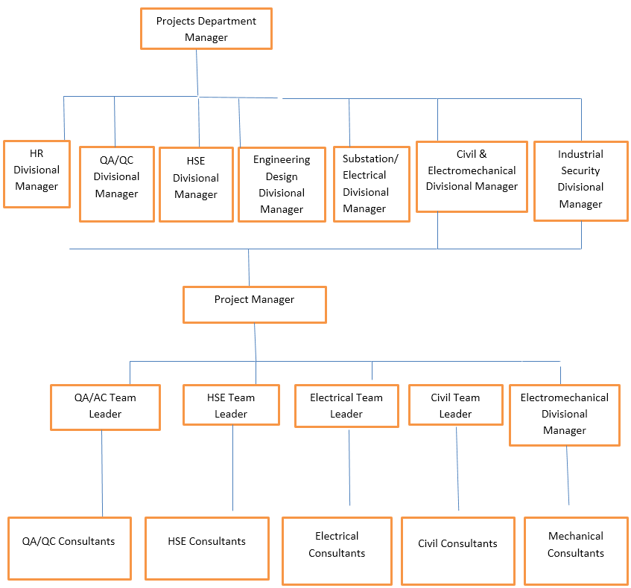
[CE 3.6] Duties:
- I made design coordination with the Design review team of the client (National Grid) and Main Contractor/sub-contractors as per PTS/SOW in compliance with SEC Engineering standards and International standards.
- I attended weekly/monthly meetings with Client/contractor/subcontractors and Vendors.
- I analyzed submitted a master schedule for meeting deadlines of electromechanical work timely in compliance with QMS & HSE procedures.
- I managed electromechanical work at sites; material inspection, installation, testing & commissioning of the HVAC system (Package Units/Ducting/Diffusers/Exhaust/Smoke Purging Fans/DDC Control Panel/Sensors/Devices), Fire Protection System (auto-detection & suppression by clean agent/portable Fire Extinguishers), Plumbing (Pumps), OHT/JIB Crane and elevator.
- I was responsible for the evaluation of site mechanical engineer from the main contractor and sub-contractors and I implemented QMS & HSE procedures.

- Personal Engineering Activity
[CE 3.7] This Scope of Work and Technical Specifications 12-WN-1000 and associated PROJECT Conceptual Design Drawings (as per Drawing Control list, attached in Part-4), describes the specific Scope Of Work that the CONTRACTOR was required to carry out on Lump Sum Turnkey (LSTK) basis until the successful completion, commissioning and Final Acceptance of WORK for AL MISFALAH-4 Substation and associated additional Work involving new additions/modifications at Makah Central BSP, South Aziziah BSP.

[CE 3.8] I performed work on LSTK basis inclusive of design, manufacture/engineering, material procurement, quality management, factory inspection/testing, transport and delivery to site, Construction, Site Inspection, Testing and Commissioning, and all associated civil/architectural/electromechanical work and services until final handing over of the Complete Plant in a satisfactorily working and operating conditions to the COMPANY as specified in this Scope of Work and Technical Specifications. All components and accessories required for the completion and successful operation of the work covered under the scope of this PROJECT, either specified in detail or not, were supplied and installed by the CONTRACTOR as necessary. I carried out the engineering design and supplied specification of equipment/materials supplied under this project which was in accordance with this scope of work and Technical Specifications and meeting the company’s standards. If the equipment either does not conform to specifications or was not acceptable to COMPANY based on past operating experience/any other reason, the contractor proposed alternative equipment for review and acceptance by the company. However, in case of a conflict in the requirements, the contractor was able to bring this to the attention of the company and obtained such applicable requirements for this PROJECT in writing from the company.

[CE 3.9] I specified the project requirements and worked on the project with the conflict management, and in case of such an eventuality, I was doing so at own risk and cost as the company reserved the right to reject any or the complete part of such work arising out of the contractor’s own decision. The engineering and design work under the contract was carried out by an engineering and design firm that has registration to carry out engineering and design work in the Kingdom of Saudi Arabia. I proposed the engineering and design work and it was linked with the company’s acceptable list of Engineering and design firms or get prequalified before the contract award for carrying out any engineering and design work for this project. I prepared the drawings with the consideration made on the scope of work and Technical Specifications were conceptual and for the information of the CONTRACTOR only. The contractor was able to read drawings in conjunction with this scope of work and technical specifications. I developed detailed design drawings for construction purposes.

[CE 3.10] After completing the Base Design, I presented the Base Design Package for technical review along with the Drawing Control Sheet. I attended the presentation meeting along with the project manager, project engineer, and construction engineer in each field of specification. Moreover, I coordinated with GIS and POWER TRANSFORMER MANUFACTURER to attend the presentation meeting with their representative(s) in each field of specification. During this meeting, the company’s comments on the base design package were reviewed and discussed in detail to finalize the base design for the project. I prepared the minutes of the meeting and concurred by the manufacturer representative and the company's representative.

[CE 3.11] I executed the fire detection and fire protection system in which I referred to the design standards. I worked on the civil and structural work in which I referred to the Technical Specifications part-5, Appendix-7, TESP, TCS, TMSS, and the related technical drawings attached in part 4 of the Tender Documents. I executed the HVAC system and met the requirements which specifically based on the specification work Part-5 per clause 5.1B.5.4.1. I met the plumbing system requirements and carried out the plumbing system specifically referring to the Civil, Structural, and electromechanical technical specification work Part-5 per clause 5.1B.3.19. I prepared a list, giving the details of the commissioning and site tests were prepared from the contractor for complete substation equipment in accordance with company testing and commissioning process (TCS-P-105) including shunt capacitor bank and submitted to the COMPANY for review and approval not less than six (6) months before the scheduled date of tests. The contractor was responsible for providing all the appropriate tools, test equipment, and temporary AC and DC power supplies needed to perform the commissioning and site tests. All tests were performed in accordance with the applicable IEC and ANSI Standards and established practices and procedures. The contractor was responsible for GIS and Power Transformer equipment site testing including installation, testing, and commissioning.

[CE 3.12] During the project activities, I followed the procedures received from the manufacturer for site installation, testing, and commissioning for the GIS and Power Transformer equipment. The contractor was able to furnish a schedule of proposed commissioning tests at least two (2) months prior to the scheduled date of tests with a list of tests and commissioning equipment with a valid calibration certificate to be used for the PROJECT. The list indicated whether each equipment is owned or to be rented. I was responsible for conducting additional tests if recommended by the equipment manufacturers or by the company. Moreover, I was responsible for the commissioning of the existing protection scheme involved with the scope of the subject project.

- Summary
[CE 3.13] The contractor was able to perform all the applicable site commissioning tests of the new equipment installed under this PROJECT including GIS and Power Transformer Equipment in accordance with applicable sections of the COMPANY Standard TCS-P-105, "Pre-Commissioning Tests/Procedures for SEC Transmission Electrical Installations". All the related work objectives were accomplished with the mechanical engineering skills used within the specified project tenure.

PROFESSIONAL ENGINEER
Summary Statement

These are the competency Units and Elements. These elements must be addressed in the Summary Statement (see Section C). If you are applying for assessment as a Professional Engineer, you will need to download this page, complete it and lodge it with your application.
Competency Element | A brief summary of how you have applied the element | Paragraph number in the career episode(s) where the element is addressed
PE1 KNOWLEDGE AND SKILL BASE
PE1.1 Comprehensive, theory-based understanding of the underpinning natural and physical sciences and the engineering fundamentals applicable to the engineering discipline | Following projects were done in the mechanical engineering field:  - Design, Review, Installation, Testing and Commissioning of HVAC, Fire-Fighting, Solar and Access Control Systems.  - Construction of New 110/13.8 kV Substation.  - Construction of New 110/13.8kV Misfilah-4 Substation. | CE 1.3, CE 2.3, CE 3.1
PE1.2 Conceptual understanding of the mathematics, numerical analysis, statistics and computer and information sciences which underpin the engineering discipline | The mechanical engineering related skills were implemented throughout the project duration for getting the desired work results. | CE 1.6, CE 2.7, CE 3.6
PE1.3 In-depth understanding of specialist bodies of knowledge within the engineering discipline | There was thorough research which I conducted related to numerous factors for obtaining the appropriate work results using mechanical engineering skills. | CE 1.8, CE 2.9, CE 3.7
PE1.4 Discernment of knowledge development and research directions within the engineering discipline | I applied research skills utilization with the mechanical engineering associated skills applied in the project for getting the desired work results. | CE 1.10, CE 2.12, CE 3.11
PE1.5 Knowledge of contextual factors impacting the engineering discipline | I made adequate analysis on project associated factors and accomplished the results within the set project timeline. | CE 1.12, CE 2.11, CE 3.10
PE1.6 Understanding of the scope, principles, norms, accountabilities and bounds of contemporary engineering practice in the specific discipline | I applied thorough research understanding on project related factors and obtained the work results within the set project timeline. | CE 1.9, CE 2.10, CE 3.7
PE2 ENGINEERING APPLICATION ABILITY
PE2.1 Application of established engineering methods to complex engineering problem solving | I applied mechanical engineering skills usage with the adequate expertise applied in the project tenure for obtaining the defined work results. | CE 1.8, CE 2.7, CE 3.6
PE2.2 Fluent application of engineering techniques, tools and resources | I made fluent engineering concepts implementation with the resources and tools utilization mainly for getting the set work results. | CE 1.10, CE 2.9, CE 3.8
PE2.3 Application of systematic engineering synthesis and design processes | I applied design processes in the work with the systematic engineering concepts for getting the specified work results. | CE 1.9, CE 2.11, CE 3.12
PE2.4 Application of systematic approaches to the conduct and management of engineering projects | I conducted appropriate research with the engineering management principles applied in the entire project tenure for obtaining the defined work results. | CE 1.7, CE 2.6, CE 3.9
PE3 PROFESSIONAL AND PERSONAL ATTRIBUTES
PE3.1 Ethical conduct and professional accountability | I executed the ethical activities in the project and was professionally accountable for carrying out the related work activities within the specified timeline. | CE 1.10, CE 2.9, CE 3.8
PE3.2 Effective oral and written communication in professional and lay domains | I worked on effective usage of written and oral communication skills in the project. | CE 1.9, CE 2.11, CE 3.12
PE3.3 Creative innovative and proactive demeanour | I understood the proactive demeanour in the project for obtaining the desired work results. | CE 1.11, CE 2.12, CE 3.10
PE3.4 Professional use and management of information | I worked on professional utilizing the mechanical engineering concepts for effectively getting the desired work results. | CE 1.7, CE 2.8, CE 3.9
PE3.5 Orderly management of self, and professional conduct | I executed the systematic conduct in the work which assisted well in gaining the desired work results in a defined time limit. | CE 1.8, CE 2.9, CE 3.11
PE3.6 Effective team membership and team leadership | I managed the project activities under the project supervisor’s assistance for obtaining the targeted work results. | CE 1.12, CE 2.10, CE 3.7

